Server Functionality

Version 1.0 March 31, 2013

The cloud based server stores the content, sends content to the displays, allows users to control the content streams being delivered and provides the ability to upload and edit the content store.

Terms:

Server: cloud based server infrastructure

Client: roku, ps3 device which connects to internet and display device

SmartDevice: an android, IOS device with which the user interacts with the server

User: a person with an account

Administrator: a member of the UA team who can perform functions on the server

Server – cloud based server infrastructure which serves up images for display

Viewlist – fixed list of images which will be displayed

Release Versions:

0 – basic demo to show to potential investors and device manufacturers

.5 – simple functional system to give to 25 “friends” to play with and give us feedback

1.0 – first system which real users can use

There is a many to many relationship between clients, users and smartdevices. A user can be associated with multiple smartdevices and clients e.g. a person has multiple TVs and both a iPad and and iPhone and wants to be able to control the TV they are looking at with whichever smartdevice is near. A client can be associated with multiple users e.g. both my wife and I are users and either of us can control the TV in the room which we are in.

Basic V0 functionality

1. Content Store – the server can store 100 images. Each image has a set of meta data fields associated with it e.g. artist name, work name, date, etc. These meta data fields need to be extensible (so we can add fields in the future) and support multiple types e.g. text, list, yes/no. Images must be loaded into the content store (no references to URLs for content).
2. Content Store editing – we need a simple web interface which allows the content store to be edited, so an administrator can upload new images and edit the associated meta data.
3. User administration – Users are entered into the system manually. (no user interface)
4. Client administration – only Roku clients are supported. Manually entered into the system. (no user interface)
5. User client association – for each user the system has a list of clients which they are authorized to use. A client can be associated for multiple users. In V0 a client is associated with a single user
6. Viewlists – an object which stores pointers to a set of images. In addition each viewlist has a name, owner and a set of extensible meta-data fields (like images) e.g. viewlist description, date created etc.
7. Viewlists – the server stores a set of viewlists. There are both public and private viewlists. In version 0 and .5 we only support public viewlists. These public viewlists are visible to all users. They are manually created by the administrator in V0
8. Client activity –Each client has an active viewlist. In V0 there is only one viewlist. When a viewlist is chosen, the first image is sent to the associated client. There is a web interface to control what is sent to the client. It shows the image being displayed on the client, the metadata associated with the image, and has forward/back buttons which allow movement through the viewlist. The image changes every 12 hours automatically. This web interface is designed to display reasonably on a web browser on the Nexus 7 tablet with 1280x800 resolution. When the end of the viewlist is reached, it starts again at the beginning. 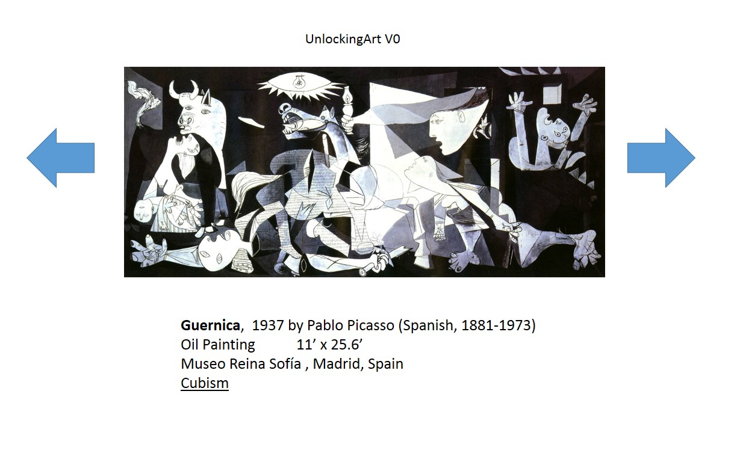
9. The server periodically sends an image to the client from the active viewlist.

Version .5 functionality

1. Content Store can store 1,000 images
2. Viewlists – the user is able to choose a viewlist to watch on their client. There are a fixed number of viewlists which are manually created by the administrator.
3. The server supports smartdevice connections. Smartdevices are only associated with a single user and single client. The smartdevice can choose a viewlist for a client, move the client forward and backward in the viewlist, display the metadata about the image being displayed on the client
4. Smartdevice support only for Nexus 7 tablet, Samsung Tab tablets and possibly other android devices.
5. Users can also use the web display interface from V0 to control their client.

Version 1.0 functionality

1. User administration – simple web interface which allows users to create/edit user accounts.
2. Client administration – some way of each client device to register itself with the server so it is authorized to use the server.
3. Content Store can store 10,000 images
4. Viewlist editing – there is a web interface which allows a user to create/edit viewlists by creating a viewlist and then selecting images from the content store to be members of the viewlist.
5. Viewlist sharing – there is a way to share viewlists between users
6. User administration – users can self register and edit their registration information.
7. Client support – support for potential other clients like ps3 and xbox 360
8. User client association – a client can be associated with multiple users (different family members can control the client with their own smartdevice)
9. Smartdevices are associated with a single user.
10. Support for IOS smartdevices